## Nuclear Force Term Cheat Sheet

### NATO Nuclear Term Glossary

#### Just a handy tool all around: <https://www.nato.int/docu/glossary/eng-nuclear/nuc_glos-e.pdf>

### Operation Types

**Countervalue** = targeting of population centers and other “civilian” infrastructure to undermine a nation

**Counterforce** = targeting of military centers and other “industrial” infrastructure to undermine a nation’s military capacity

**Damage limitation** = pre-emptive strike (either conventional or nuclear) in response to a perceived imminent attack and/or escalation of conventional hostilities

**Nuclear sharing** = how nation states decide to utilize their own national nuclear forces to assure allies/partners and deter threats to said alliances/partnerships – outlined in great detail here: <https://media.nti.org/pdfs/NTI_Framework_Chpt4.pdf>

### Offensive Weapons Systems

**Super fuse Warheads** = newer invention, allows for the remote detonation of warheads before/after penetration by the missile – allows for more accurate targeting and better bunker busting – allows SLBMs to compete with ICBMs for counterforce missions – below are the differences in detonation spread and force exerted

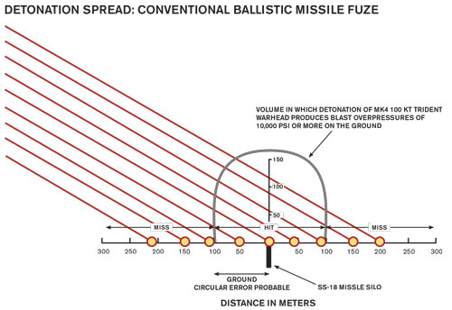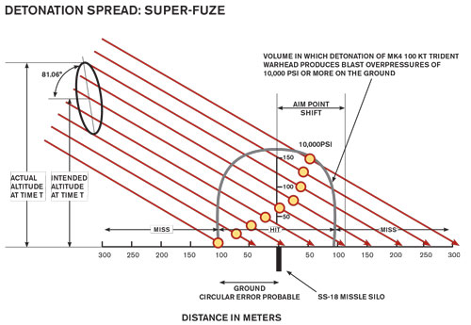

https://thebulletin.org/multimedia/the-super-fuze-picture/

**ICBMS** = Intercontinental Ballistic Missiles, travel in a high arc that “leaves” (read: goes to the highest level of) the atmosphere before returning back to earth to strike its intended target(s)

**IRBMS** = Intermediate Range Ballistic Missiles, same as ICBMS but with just shorter range (500-1200 km)

**SLBMS** = Submarine-Launched Ballistic Missiles, same arc as ICBMs but launched from stealth positions in the ocean, most of our boomers travel in pairs and are the *stealthiest* arm of the triad as well as the stealthiest across nation-states – most of this is due to the fact the US has seeded basically the entire ocean with sonar sensors that are really good at picking up on submarine engine activity (its why China’s subs are consider “super noisy”)

**Cruise Missiles** = travel immediately in a high arc before quickly plateauing and using its glide mechanism to stay in lower altitudes/avoiding detection, differing delivery vehicle design

**Hypersonic Missiles** = usually cruise/glider missiles, travel faster than ICBMs or Cruise Missiles, delivery vehicle

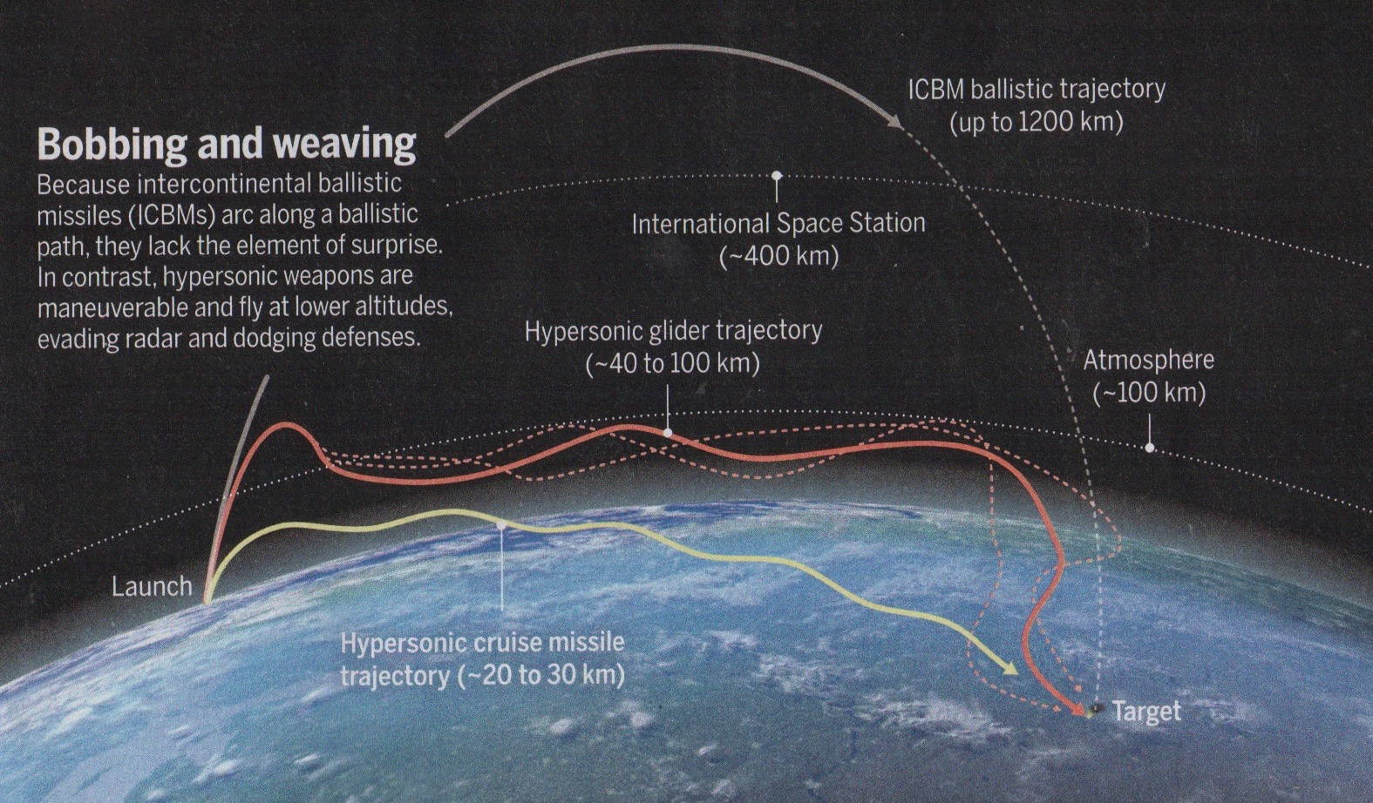

<https://www.google.com/url?sa=i&url=https%3A%2F%2Fsimanaitissays.com%2F2020%2F01%2F23%2Fthe-hypersonic-arms-race%2F&psig=AOvVaw1MdUhfjurmgfqJ7x3BIgSP&ust=1604065659405000&source=images&cd=vfe&ved=0CAIQjRxqFwoTCNCfzbX42ewCFQAAAAAdAAAAABAg>

**Bombers** = the “aircraft” arm of the nuclear triad, the most stable of the 3 as planes can be recalled at a moment’s notice but missiles cannot, only method through which a nuclear bombing of an adversary has taken place – considered the “strategic” or “tactical” arm of nuclear operations

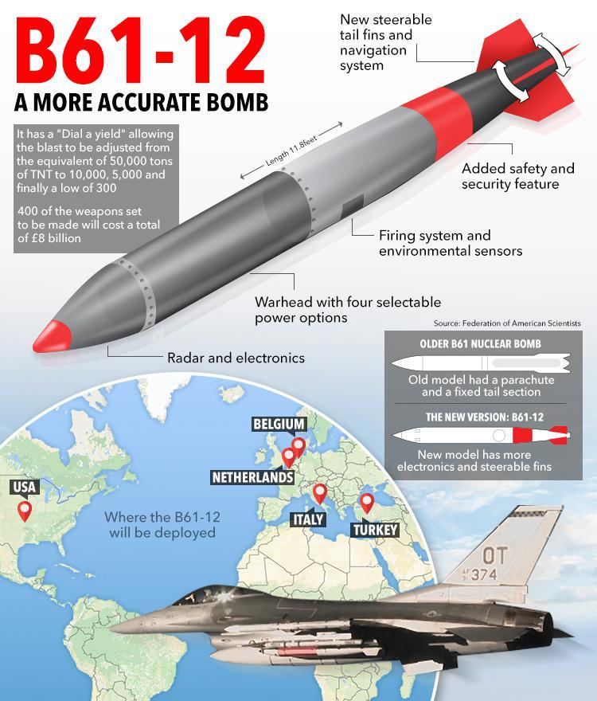

### Defense Weapons Systems

**BMD** = Ballistic Missile Defense, also know as the corner of military research with the overly busy graphs, refers to a range of systems including THAAD, Aegis, and others – basically these systems differ on where they plan to *intercept* incoming missiles and *how* those interceptions go down (kinetic v laser v emp, etc.)

Systems like **Aegis** are *mid-course* interceptors meant to destroy missiles are they are hitting the arc/glide portion of their trajectory

Systems like **THAAD** are *Terminal Defense* interceptors meant to destroy missiles as the launch vehicle separates from the warhead as they are entering back into the lower atmosphere

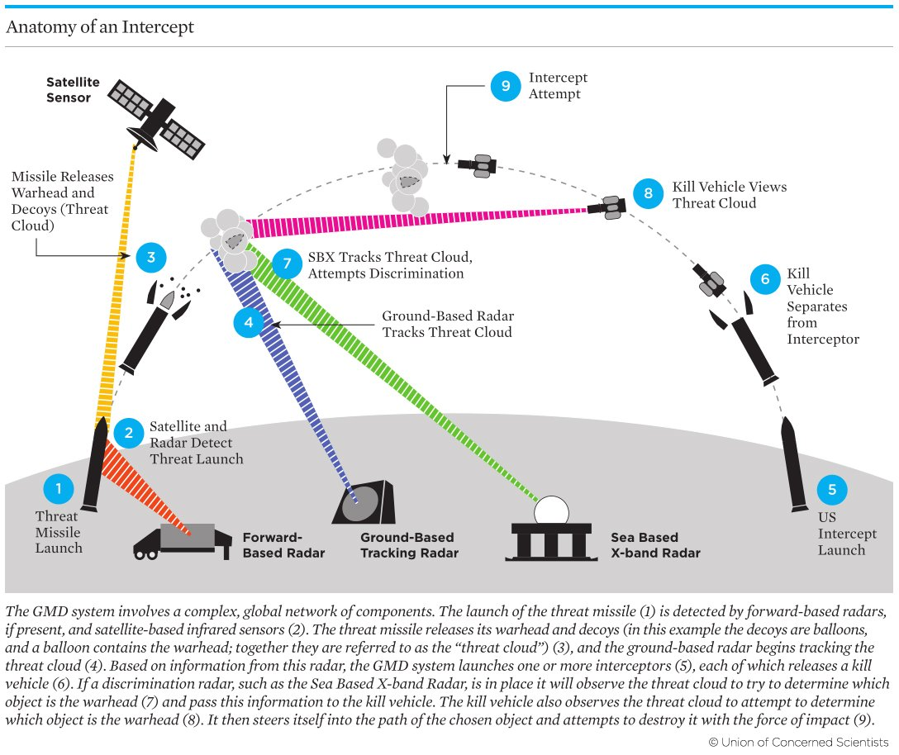

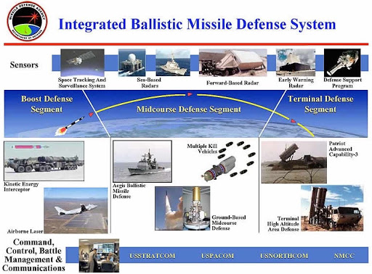

https://lh3.googleusercontent.com/proxy/dCgPRZI69b7Itr4VrZB0vzfgujD5nTUHNV-KoKpyiMdTJtkG3ZHlxfKJKctRiW5U1tM0NYm2LsZJQuZ4oQx0-eDjkHwYJiWzKJ-9

## Definition Work Proper

### Nuclear “Delivery” System/Vehicle

#### Nuclear delivery systems comprise of ballistic missiles, cruise missiles, combat aircraft, and drones which are reduced through arms control, missile defense, and regulation of trade/sharing

NTI No Date, NTI, in partnership with the James Martin Center for Nonproliferation Studies, has developed this set of educational tutorials to build understanding among a new generation of experts and leaders on these often complex issues. The interactive tutorials include overviews of key issues, a glossary, maps, quizzes and more., “Missiles & Other WMD Delivery Systems – Module 1: Introduction”, https://tutorials.nti.org/delivery-system/introduction/

**Delivery systems―such as ballistic and cruise missiles, combat aircraft, and drones―determine how, when, and against whom a country can use conventional, nuclear, chemical, or biological weapons**.

Today over 30 countries possess ballistic missiles, over 20 have cruise missiles, many more operate combat aircraft, and others are pursuing these technologies. Their proliferation increases the risk additional countries will be able to carry out WMD attacks, and fuels regional and global instability through arms racing.

**Countries have turned to a variety of diplomatic and military tools to address the proliferation of delivery systems, including arms control agreements, missile defense capabilities, and cooperative mechanisms to regulate trade in delivery systems and interdict their illicit shipment**.

#### Nuclear certified delivery vehicle definition

NATO and NATO-Russia Nuclear Terms and Definitions ’07, “PART 1 Nuclear Terms and Definitions in English APPENDIX 1 NATO and NATO-Russia Nuclear Terms and Definitions APPENDIX 2 Non-NATO Nuclear Terms and Definitions APPENDIX 3 Definitions of Nuclear Forces”, https://www.nato.int/docu/glossary/eng-nuclear/nuc_glos-e.pdf

**nuclear certified delivery vehicle**

A delivery vehicle whose compatibility with a nuclear weapon has been certified by the applicable nuclear power through formal procedures (AAP-6). **See also nuclear delivery vehicle**.

vecteur homologué nucléaire

средство доставки, сертифицированное для ядерного применения

#### Nuclear delivery vehicle definition

#### Non-NATO Nuclear Terms and Definitions ’07, “PART 1 Nuclear Terms and Definitions in English APPENDIX 1 NATO and NATO-Russia Nuclear Terms and Definitions APPENDIX 2 Non-NATO Nuclear Terms and Definitions APPENDIX 3 Definitions of Nuclear Forces”, https://www.nato.int/docu/glossary/eng-nuclear/nuc_glos-e.pdf

**nuclear delivery vehicle**

1. **Nuclear delivery vehicle is a means to carry and delivery a nuclear munition to the target** (RF).

2. That portion of the weapon system which provides the means of delivery of a nuclear weapon to the target (AAP-6). **See also nuclear certified delivery vehicle**.

vecteur à capacité nucléaire

средство доставки ядерного боеприпаса

### Nuclear “Forces”

#### First search with this term brings up a bunch of science terms related to how nuclear atoms/molecules interact – specifying military results in “nuclear force posture”, “nuclear force structure”, “command and control of nuclear forces”, and “nuclear commands, control, and communication (nc3)” which are the relevant terms of interest

#### This article is interesting because it lays out the mechanisms through which “nuclear force” aka the weapon systems that make up the deployed arsenal can only be reduced through arms reduction or obsolescencewhich seems to indicate that changing the make-up of deployed weapons is viable with this wording choice, but would have to intentionally specify reduce and/or modify*\**

**\*modify can be replaced with better terms that fit the literature – this is just my personal word choice to communicate thoughts**

GEORGE PERKOVICH and PRANAY VADDI ’21, *is the Ken Olivier and Angela Nomellini Chair and vice president for studies at the Carnegie Endowment for International Peace. Perkovich works primarily on nuclear strategy and nonproliferation issues; cyberconflict; and new approaches to international public-private management of strategic technologies., **is a fellow in the Nuclear Policy Program at the Carnegie Endowment for International Peace., “Nuclear Force Posture and Nuclear Command, Control, and Communications”, Carnegie Endowment for International Peace, 1/21/21, https://carnegieendowment.org/2021/01/21/nuclear-force-posture-and-nuclear-command-control-and-communications-pub-83581

The best nuclear force would be one that is:

* credible enough to deter adversaries and reassure allies and partners;
* least likely to provoke escalation if deterrence fails but could survive adversary escalation if it occurred; and
* would not cause more destruction than necessary to meet wartime objectives.

Such a force is hard to design in theory and harder to maintain in practice. Nuclear weapons systems take years to fund, design, develop, produce, and deploy. **Once they are deployed, they are expected to remain in the arsenal for decades unless they are eliminated through arms reductions or obsolescence**. The longevity of the arsenal may impede its adaptability to changing global security dynamics.

**And so, the triad**. For five decades, the United States has had a triad of nuclear weapon delivery systems, based on sea, air, and land. This arrangement developed through competition between the Air Force and the Navy for a share of the nuclear mission, and the evolution of available delivery technologies thereafter.1 Only after the triad was in place did strategists and officials enshrine its virtues.2 It gradually became sacrosanct and vital to the Air Force, the Navy, the eleven states that host triad delivery systems, and the many other states and enterprises that produce these systems. Alongside it, an NC3 system was designed to survive the stresses of nuclear conflict.

#### The “main force structure” refers to triad pieces – air, sea, and land which comprises of a few different parts in the United States for each to maintain “politically acceptable” deterrence force structure:

**Air** – Bombers, LRSO (new ALCM), B61 Bomb (gravity bomb with a few different yields – low and variable, with the Mod 12 undergoing upgrades and Mod 11 maintaining service as a earth-penetrator) – mostly deployed overseas through NATO

**Sea** – SSBNs, Trident SLBMs, Low-Yield Trident D5 (LYD5), SLCM-N

**Land** – ICBMS (400 Minutemen III – deployed in Colorado, Montana, Nebraska, North Dakota, and Wyoming – MIRV capable, but only one warhead each)

#### The unfortunate part though is that “forces” or “force structure” also could refer to NC3 as a distinct portion which massively adds to what the aff can do/skirts the main question that this resolution is trying to develop imo, though there is a debate to be had about whether it is the organizational/informational structure of nuclear forces that maintains them or is a distinct force itself. This could make a case for simply “nuclear weapons” as it is clearly distinguished from NC3, but still maintains the triad pieces discussed above. However, I still think the NC3 thing is totally a debate to be had if forces is chosen, rather than a super large concern, so I still lean towards the use of this term

GEORGE PERKOVICH and PRANAY VADDI ’21, *is the Ken Olivier and Angela Nomellini Chair and vice president for studies at the Carnegie Endowment for International Peace. Perkovich works primarily on nuclear strategy and nonproliferation issues; cyberconflict; and new approaches to international public-private management of strategic technologies., **is a fellow in the Nuclear Policy Program at the Carnegie Endowment for International Peace., “Nuclear Force Posture and Nuclear Command, Control, and Communications”, Carnegie Endowment for International Peace, 1/21/21, https://carnegieendowment.org/2021/01/21/nuclear-force-posture-and-nuclear-command-control-and-communications-pub-83581

**Nuclear weapons are only as reliable (physically) as the command, control, and communication systems that inform and implement the decisions to employ or not employ them.** These systems **(known as NC3) are supposed to**:70

* **guarantee effective monitoring and exclusive control at all times over all nuclear forces and strategic operations;**
* **support decisionmaking, planning, and operations in all scenarios;**
* provide timely warning of imminent attack;
* supply situational awareness to the various command levels;
* assure effective and secure communications to and from national command authority;
* accommodate and support required maintenance, upgrade, safety and surety operations;
* withstand efforts to undermine or subvert the reliable transmission of information and guidance between and across command levels; and
* sustain high standards of safety, security, and secrecy commensurate with the sensitivity of nuclear weapons.

The U.S. NC3 system includes space- and terrestrial-based sensors and communications platforms, as well as the computer architecture and other hardware that make these platforms work. The Pentagon currently plans to modernize the NC3 system wholesale. The Congressional Budget Office estimates that this effort will cost $77 billion from 2019 to 2028.71

#### The United States independently defines “nuclear forces” in 3 categories – each of which refer to a different role played by said forces

NATO No Date, “Definitions of Nuclear Forces”, Part 1, Appendix 3, <https://www.nato.int/docu/glossary/eng-nuclear/eng-app3.pdf> **References – USIA: U.S. Information Agency – Arms Control and Disarmament – Glossary of Terms, USDoD: U.S. Department of Defense Dictionary of Military and Associated Terms, CP&MT: NATO-Russia Glossary of Contemporary Political and Military Terms

**United States**

**Non-strategic nuclear forces**

Those nuclear-capable forces located in an operational area with a capability to employ nuclear weapons by land, sea, or air forces against opposing forces, supporting installations, or facilities. Such forces may be employed, when authorized by competent authority, to support operations that contribute to the accomplishment of the commander’s mission within the theatre of operations. (USDoD)

**Theater nuclear forces**

Nuclear forces designed for localized military missions. (USIA)

**Strategic nuclear forces**

Land-based ballistic missiles with ranges over 5500 kilometres, modern submarine-launched ballistic missiles, and heavy bombers. (USIA)

#### Nuclear forces refers to the stockpile of warheads that nation states assign to operational roles and/or missions even if not in weapon format

HANS KRISTENSEN, MATT KORDA, ELIANA JOHNS, and KATE KOHN ’23, *is Director of the Nuclear Information Project at the Federation of American Scientists where he provides the public with analysis and background information about the status of nuclear forces and the role of nuclear weapons., **is a Senior Research Associate and Project Manager for the Nuclear Information Project at the Federation of American Scientists, where he co-authors the Nuclear Notebook––an authoritative open-source estimate of global nuclear forces and trends. Matt is also an Associate Researcher with the Weapons of Mass Destruction Programme at the Stockholm International Peace Research Institute (SIPRI), and co-authors the nuclear weapons chapters for the annual SIPRI Yearbook, ***is a Research Associate for the Nuclear Information Project at the Federation of American Scientists, where she researches the status and trends of global nuclear forces and the role of nuclear weapons., ****is the Communications Manager for the Federation of American Scientists., “Status Of World Nuclear Forces”, Federation of American Scientists, 3/31/23, https://fas.org/initiative/status-world-nuclear-forces/

Who owns the world’s nuclear weapons?

Despite progress in reducing nuclear weapon arsenals since the Cold War, the world’s combined inventory of nuclear warheads remains at a very high level: nine countries possessed roughly 12,500 warheads as of early-2023.

Combined, the United States and Russia now possess approximately 89 percent of the world’s total inventory of nuclear weapons, and 86 percent of the stockpiled warheads available for use by the military. Currently, no other nuclear-armed state sees a need for more than a few hundred nuclear weapons for national security, although many of these states are increasing their nuclear stockpiles.

Globally, the overall inventory of nuclear weapons is declining, but the pace of reductions is slowing compared with the past 30 years. Moreover, these reductions are happening only because the United States and Russia are still dismantling previously retired warheads.

**In contrast to the overall inventory of nuclear weapons, the number of warheads in global military stockpiles** – which comprises warheads assigned to operational forces – **is increasing once again.** The United States is still reducing its nuclear stockpile slowly. France and Israel have relatively stable inventories. But China, India, North Korea, Pakistan and the United Kingdom, as well as possibly Russia, are all thought to be increasing their stockpiles (see map):

**Of the world’s approximate 12,500 nuclear warheads, roughly 9,576 are in the military stockpiles for use by missiles, aircraft, ships and submarines**. The remaining warheads have been retired but are still relatively intact and are awaiting dismantlement). Of the 9,576 warheads in the military stockpiles, some 3,804 are deployed with operational forces (on missiles or bomber bases). Of those, approximately 2,000 US, Russian, British and French warheads are on high alert, ready for use on short notice (see table):

**Estimated Global Nuclear Warhead Inventories, 2023**

HANS M. KRISTENSEN, MATT KORDA, AND ELIANA REYNOLDS, FEDERATION OF AMERICAN SCIENTISTS, 2023

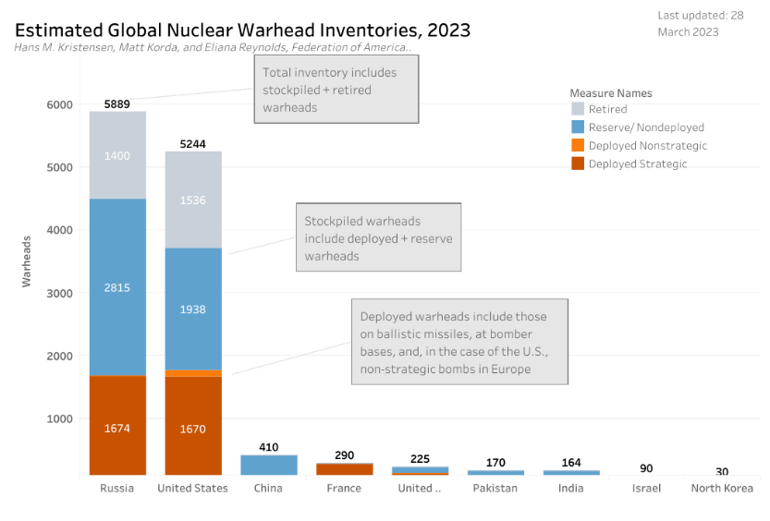

#### Conventional-nuclear force entanglement conversations are ensured with this term because it questions the “status” and “role” that nuclear forces play within national military strategy

Justin Anderson and James R. McCue ’21, *Dr. Anderson is a senior policy fellow at the Center for the Study of Weapons of Mass Destruction at National Defense University, **Lt Col USAF and serves as a nuclear strategist at the Defense Threat Reduction Agency, “Deterring, Countering, and Defeating Conventional-Nuclear Integration”, Strategic Studies Quarterly – Perspective, Spring 2021, https://www.airuniversity.af.edu/Portals/10/SSQ/documents/Volume-15_Issue-1/Anderson.pdf

An important component of their approach is integrating conventional and nuclear-capable forces into their political-military strategies. For advanced militaries, nuclear-capable forces include delivery systems that are solely devoted to a nuclear role and dual-capable platforms that can carry either conventional or nuclear weapons (and whose status and armaments may be unclear to a potential opponent). All three states have developed and deployed both long-range “strategic” nuclear-armed missiles and theater-range (i.e., short-, medium-, or intermediate-range) nuclearcapable delivery systems, with the latter serving alongside, or intermixed with, their conventional forces.2 These integrated forces provide these actors with the ability to develop combined arms theater campaign plans bringing conventional and nuclear capabilities to bear against US and allied forces within a future potential regional conflict.3 As stated by Brad Roberts, former deputy assistant secretary of defense (DASD) for nuclear and missile defense policy, the “United States must expect that nuclear weapons would play a role in regional wars against Russia or China,” as both Moscow and Beijing have incorporated nuclear coercion, and potential employment, into their “theories of victory” for these types of conflicts.4 Roberts further assesses that North Korea’s nuclear weapons and missile development programs may have granted it “operationally attractive” options for a “credible anti-access area-denial strategy” against the United States and South Korea within a future conflict on the Korean Peninsula.5 Keith Payne, who also previously served in this DASD role, shares many of these same concerns. In 2018 he noted, “We must understand how to deter Great Powers and nuclear-armed Rogues from exploiting limited nuclear threats and/or escalation for coercive purposes in support of their respective goals to change established orders and borders in Europe [and] Asia.”6

For US policy makers, it is important to recognize that present efforts to address the challenge posed by conventional-nuclear integration (CNI) can be informed by the Cold War, when the Soviet Union attempted to utilize a combination of conventional forces and theater-range nuclear delivery systems to threaten and attempt to fracture the North Atlantic Treaty Organization (NATO).7 The United States met this challenge with its own integrated conventional-nuclear force, with the allied regional defense posture relying on the US arsenal of “non-strategic” nuclear weapons to counter the Warsaw Pact’s significant advantage in conventional forces.8 **Critically, however, the present CNI threat from adversaries combines both of these concepts**. Russia, China, and North Korea field integrated forces to challenge US regional defense alliances and deterrence postures while also viewing CNI as necessary to offset what they assess as contemporary US advantages in conventional forces.

**As a result, while aspects of the present situation echo the Cold War, today’s CNI environment is more complex than in the past era**. **The United States must address the challenge of three potential adversaries fielding integrated conventional and nuclear forces, to include new theater-range, nuclear-capable mobile missiles recently fielded by each state**. Our proposed counter-CNI strategy seeks to adapt to today’s multipolar context, a half century of technological achievement, and the important fact that the United States is less reliant on nuclear weapons to impose costs on an opponent’s military forces within future regional conflicts than its potential adversaries. US policies and strategies for countering the evolving and cross-cutting CNI threat thus requires an integrated, but not mirror-imaged, response. **It should leverage US conventional and nuclear-capable forces to enhance regional deterrence and defeat options, without mimicking potential adversaries by overly and dangerously relying on the threat or use of nuclear weapons in theater to prevail in a potential future regional conflict**.

#### CNI definition proper – avoids questions of accidental entanglement, has to be a purposeful strategy by a nationstate

Justin Anderson and James R. McCue ’21, *Dr. Anderson is a senior policy fellow at the Center for the Study of Weapons of Mass Destruction at National Defense University, **Lt Col USAF and serves as a nuclear strategist at the Defense Threat Reduction Agency, “Deterring, Countering, and Defeating Conventional-Nuclear Integration”, Strategic Studies Quarterly – Perspective, Spring 2021, https://www.airuniversity.af.edu/Portals/10/SSQ/documents/Volume-15_Issue-1/Anderson.pdf

**CNI is a subset of the broader phenomena of nuclear-conventional “entanglement,” a term referring to the ways and means by which conventional and nuclear forces may intersect, interconnect, and/or overlap**.10 Importantly, entanglement does not necessarily attribute intentionality to this interrelationship. Research on this subject often focuses on areas of entanglement that may be unintentional and, therefore, are either reversible or can be otherwise addressed to reduce the risk that overlap could lead to nuclear crisis or conflict.11

**We define CNI as the deliberate, calculated decision by a state actor to combine conventional and nuclear-capable forces for the purpose of realizing strategic, theater, and/or tactical military objectives that it assesses cannot be achieved through the use of conventional forces alone**. This intentionality extends across a spectrum of activities associated with fielding military forces. These include researching and developing delivery systems and weapons that can fit into an integrated force (such as dual-capable missiles that can carry conventional or nuclear warheads); organizing, training, and equipping both conventional and nuclearcapable military forces; preparing, planning, and training these forces to operate together; and openly conducting tests or exercises for combined operations, demonstrating how one type can support or enable the other and/or making clear to outside audiences that nuclear-capable forces are integral to theater war-fighting concepts. The focus here is on the integration of conventional and nuclear-capable forces by Russia, China, and North Korea as actors that represent potential adversaries of the United States. It is important to note, however, that CNI is a broader phenomenon that also extends to states such as Pakistan, which has integrated short- and medium-range nuclear-capable forces into strategies and plans for defending its territory against a potential cross-border offensive by large numbers of Indian conventional forces.12

### Nuclear “Weapon”

#### Atomic or thermonuclear/hydrogen bombs who derive destructive potential from nuclear fission and/or fusion respectively

Robert S. Norris and Thomas B. Cochran 6/1/23, *Dr. Norris was a senior research associate with the Natural Resources Defense Council in Washington, DC from 1984 to his retirement in 2011. His principal areas of expertise include writing and research on all aspects of the nuclear weapons programs of the United States, Soviet Union/Russia, Britain, France, and China, as well as India, Pakistan, and Israel., **Dr. Thomas B. Cochran is a consultant to the Natural Resources Defense Council where he began working in 1973. Prior to retiring in 2011, he was a senior scientist and held the Wade Greene Chair for Nuclear Policy at NRDC, and was director of its Nuclear Program until 2007. He has served as a consultant to numerous government and non-government agencies on energy, nuclear nonproliferation, nuclear reactor and nuclear waste matters., “nuclear weapon”, Britannica, 6/1/23 – last edit, https://www.britannica.com/technology/nuclear-weapon/Other-countries

**nuclear weapon, device designed to release energy in an explosive manner as a result of nuclear fission, nuclear fusion, or a combination of the two processes**. **Fission weapons are commonly referred to as atomic bombs. Fusion weapons are also referred to as thermonuclear bombs or, more commonly, hydrogen bombs**; they are usually defined as nuclear weapons in which at least a portion of the energy is released by nuclear fusion.

The first nuclear weapons were bombs delivered by aircraft. Later, warheads were developed for strategic ballistic missiles, which have become by far the most important nuclear weapons. Smaller tactical nuclear weapons have also been developed, including ones for artillery projectiles, land mines, antisubmarine depth charges, torpedoes, and shorter-range ballistic and cruise missiles.

#### Device that uses a nuclear reaction to create an explosive in the form of a bomb or missile

Centers for Disease Control and Prevention CDC ’19, “Nuclear Weapon”, Environmental Health Infographics, 12/16/19 – last reviewed, https://www.cdc.gov/nceh/multimedia/infographics/nuclear_weapon.html

**A nuclear weapon is a device that uses a nuclear reaction to create an explosion**. This explosion is much more powerful than that of conventional explosives (like TNT). When a nuclear weapon explodes, it gives off four types of energy: a blast wave, intense light, heat, and radiation. **Nuclear weapons can be in the form of bombs or missiles**.

When a nuclear weapon explodes, a large fireball is created. Everything inside of this fireball vaporizes and is carried upward. This creates a mushroom-shaped cloud. The material in the cloud cools into dust-like particles and drops back to the earth as fallout. Fallout can be carried by the wind and can end up miles from the site of the explosion. Fallout is radioactive and can contaminate anything it lands on.

#### Explosive device whose destructive potential derives from atomic nuclei

Dictionary.com No Date, “nuclear weapon”, https://www.dictionary.com/browse/nuclear-weapon

noun **an explosive device whose destructive potential derives from the release of energy that accompanies the splitting or combining of atomic nuclei**.